Additional documentation for interaction with screenshots:
Original page [page 5] :
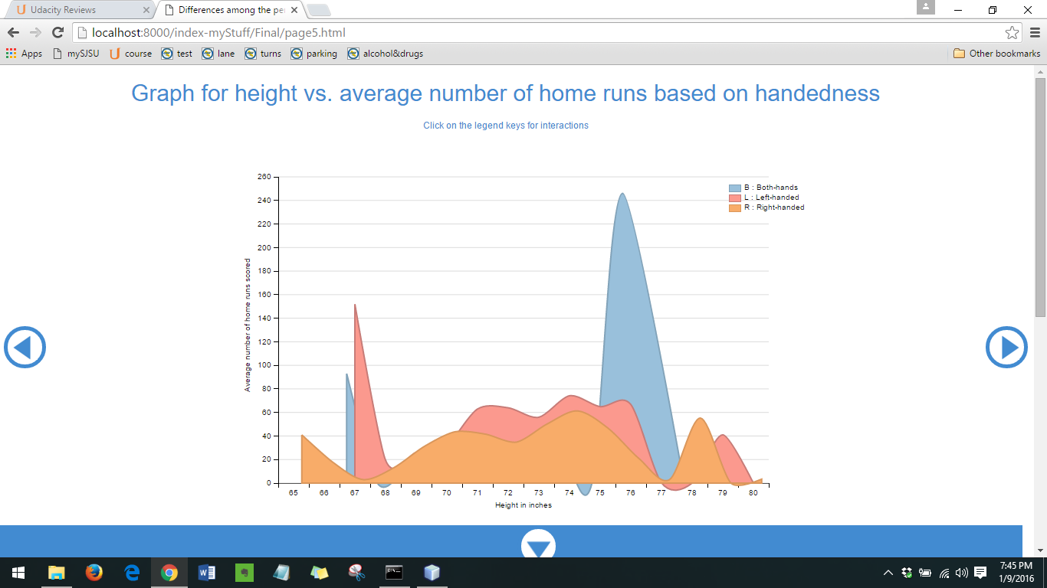
After clicking on the “blue” legend key, we get the following –
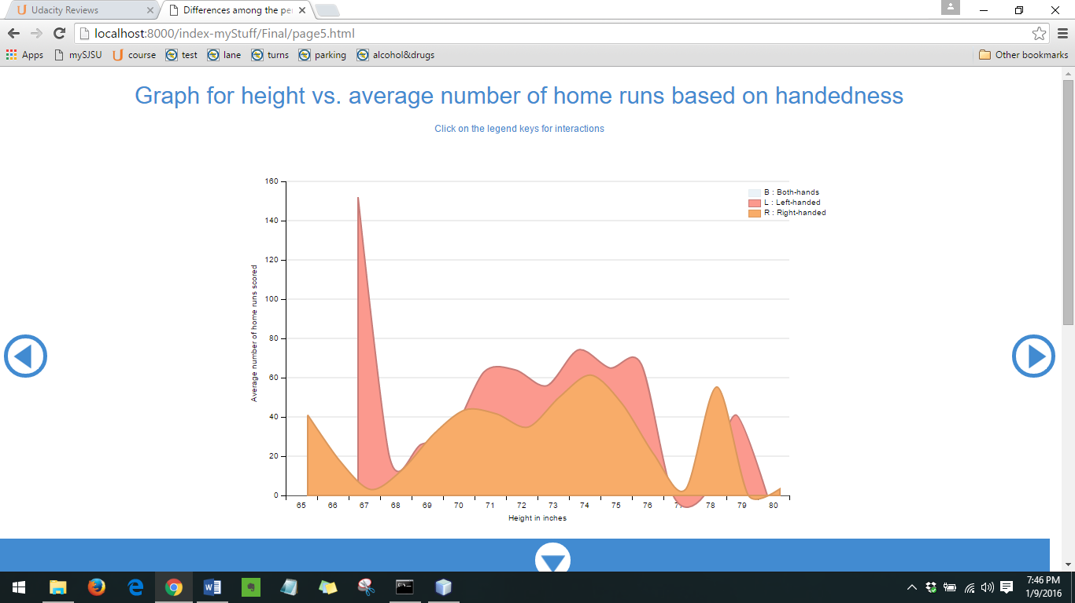
After clicking on the “orange” legend key, we get the following –
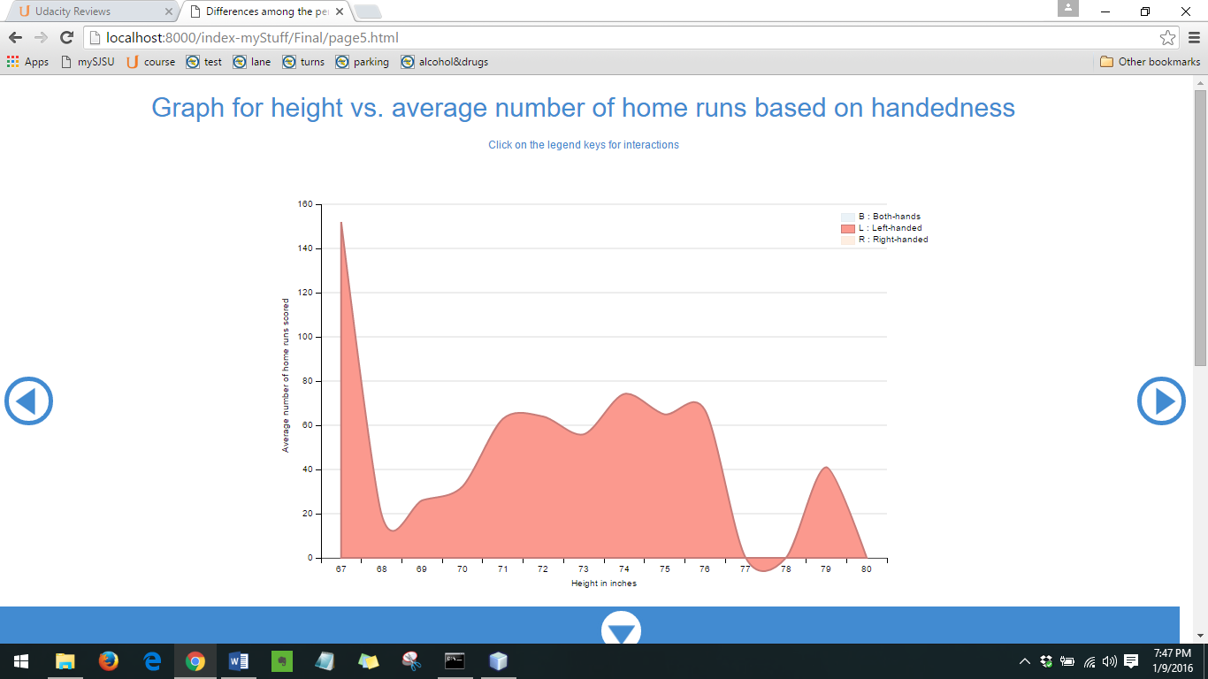

After clicking on the “blue” legend key again [previously unselected], we get the following –
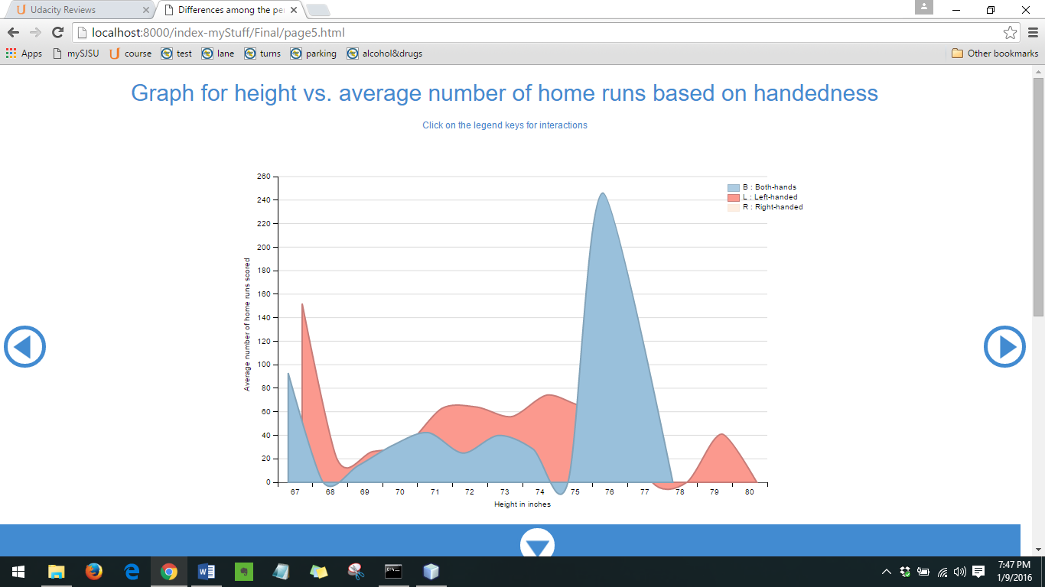
Similar actions can be performed on the other legends. Additionally, all these features work with the similar graph on page 3.

